TUTORIAL 2 – SCREENSHOT REPORT
LOGIN / REGISTRATION
Website: Automation Exercise
TC01 – Registration
Test Case | Check that a new user can create an account using valid details.
Execution | Open the website → Click Signup / Login → Enter name and unique email → Click Signup → Fill account details → Click Create Account
Test Data | Unique email / valid password
Expected Result | Account should be created and the message 'ACCOUNT CREATED!' should be shown.
Actual Result | The registration flow reaches account creation successfully
Status | PASS
Screenshot:
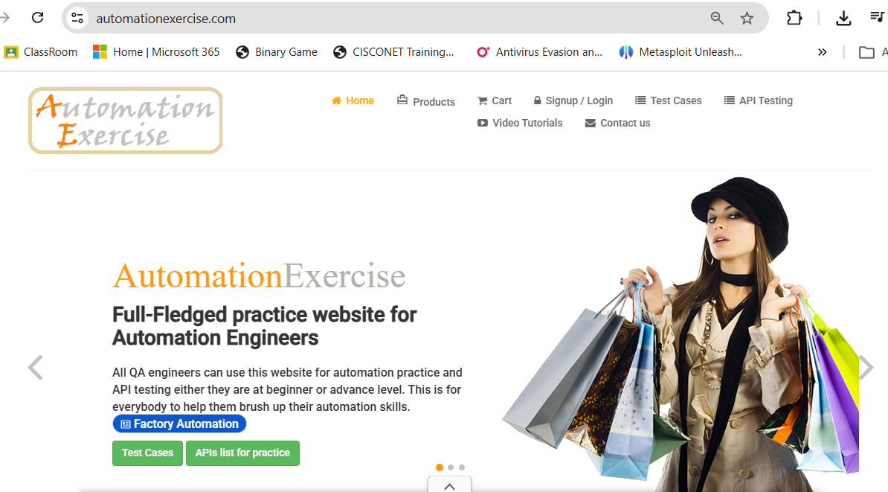
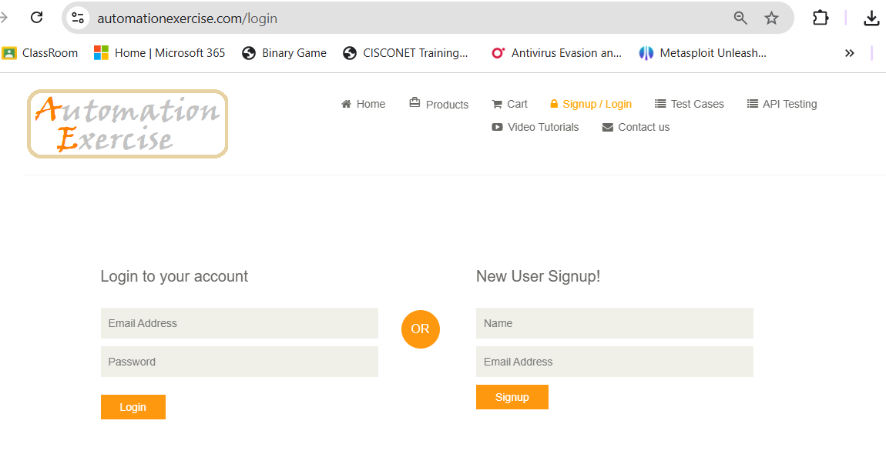
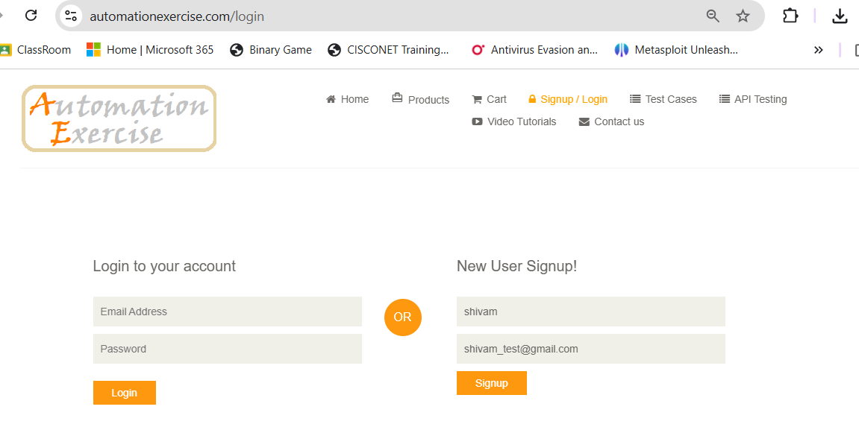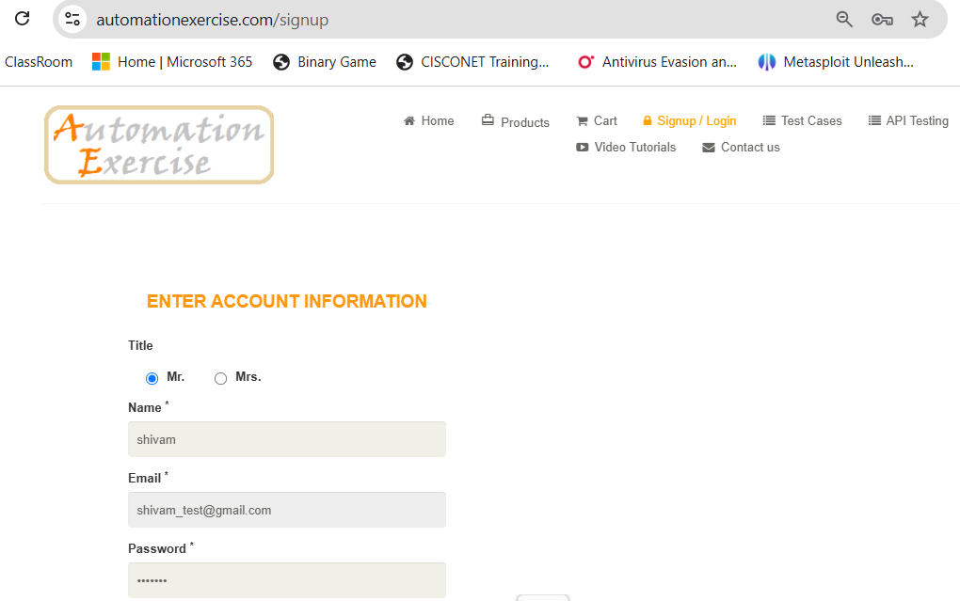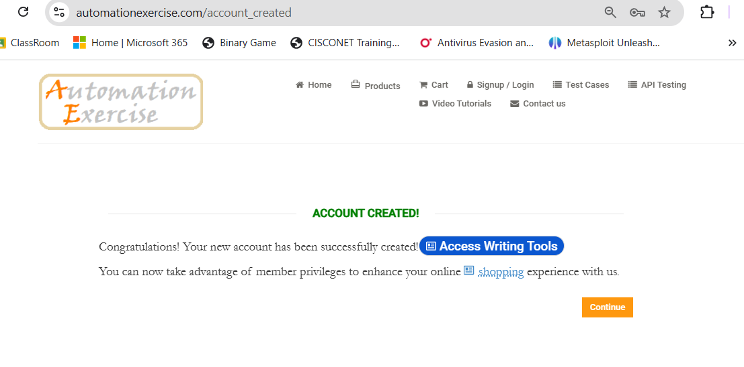

TC02 – Invalid Registration
Test Case | Check that the website does not accept invalid registration details.
Execution | Open Signup / Login → Enter invalid or incomplete details → Submit the form
Test Data | Invalid email / incomplete required fields
Expected Result | The registration should not be completed and a validation message should be shown.
Actual Result | Invalid registration data is rejected and validation is displayed.
Status | PASS
Screenshot:
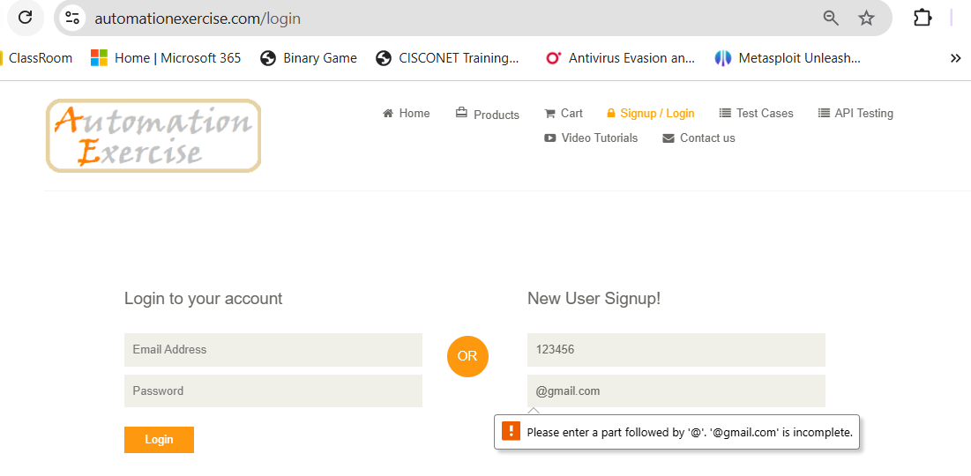

TC03 – Existing Email Registration
Test Case | Check that an already registered email cannot be used again.
Execution | Open Signup / Login → Enter name → Enter existing email → Click Signup
Test Data | Existing registered email
Expected Result | The website should show 'Email Address already exist!'.
Actual Result | The existing email is rejected with the duplicate-email message.
Status | PASS
Screenshot:
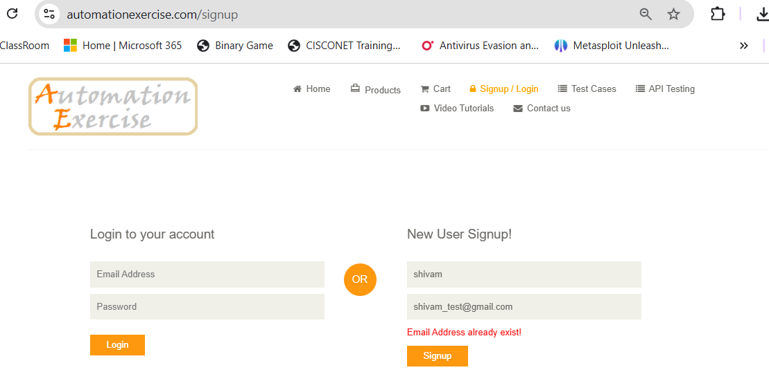

TC04 – Valid Login
Test Case | Check that a registered user can log in with correct credentials.
Execution | Open Signup / Login → Enter registered email and password → Click Login
Test Data | Registered email / correct password
Expected Result | The user should be logged in and 'Logged in as username' should be visible.
Actual Result | Login is successful and the logged-in state is displayed.
Status | PASS
Screenshot:
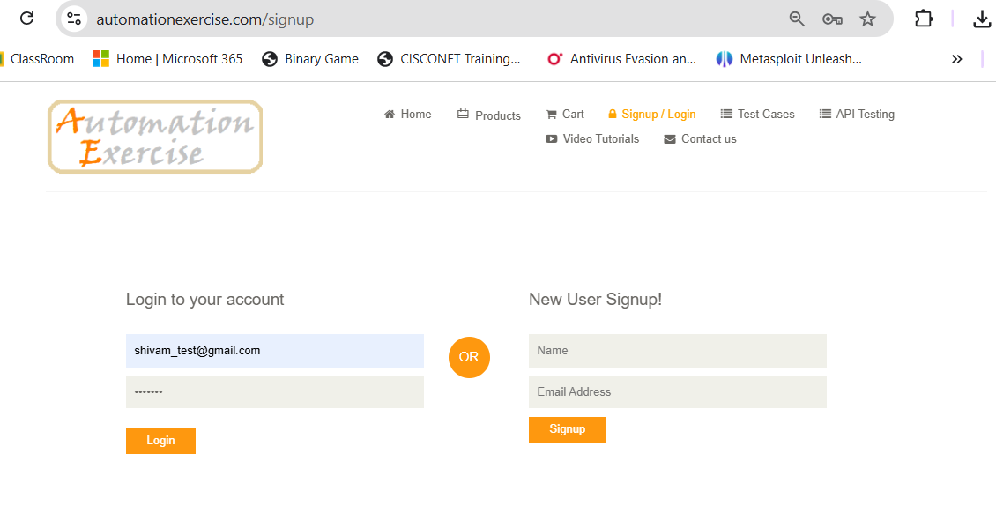


TC05 – Invalid Email
Test Case | Check that login does not work with an invalid email.
Execution | Enter an invalid email → Enter password → Click Login
Test Data | wrong-email@example.com / any password
Expected Result | The website should show 'Your email or password is incorrect!'.
Actual Result | Login is rejected and the incorrect-credentials message is displayed.
Status | PASS
Screenshot:
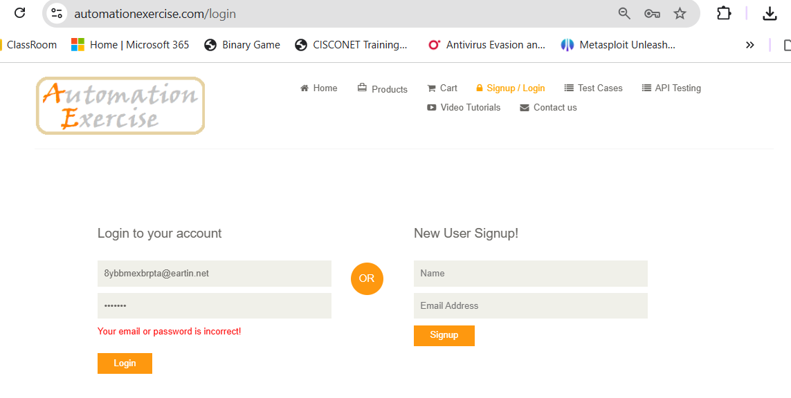

TC06 – Invalid Password
Test Case | Check that login does not work with a wrong password.
Execution | Enter registered email → Enter wrong password → Click Login
Test Data | Registered email / wrong password
Expected Result | The website should show 'Your email or password is incorrect!'.
Actual Result | Successfully Login.
Status | Fail
Screenshot:
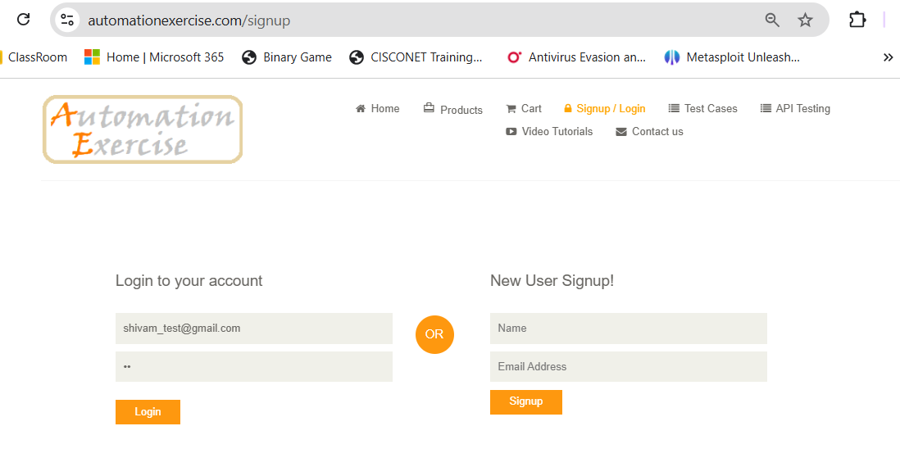


TC07 – Blank Username
Test Case | Check that login cannot continue when the username/email field is blank.
Execution | Leave username/email blank → Enter password → Click Login
Test Data | Blank username/email / Abc@123
Expected Result | Login should not be successful and the required-field validation should appear.
Actual Result | Login does not proceed with a blank username/email.
Status | PASS
Screenshot:
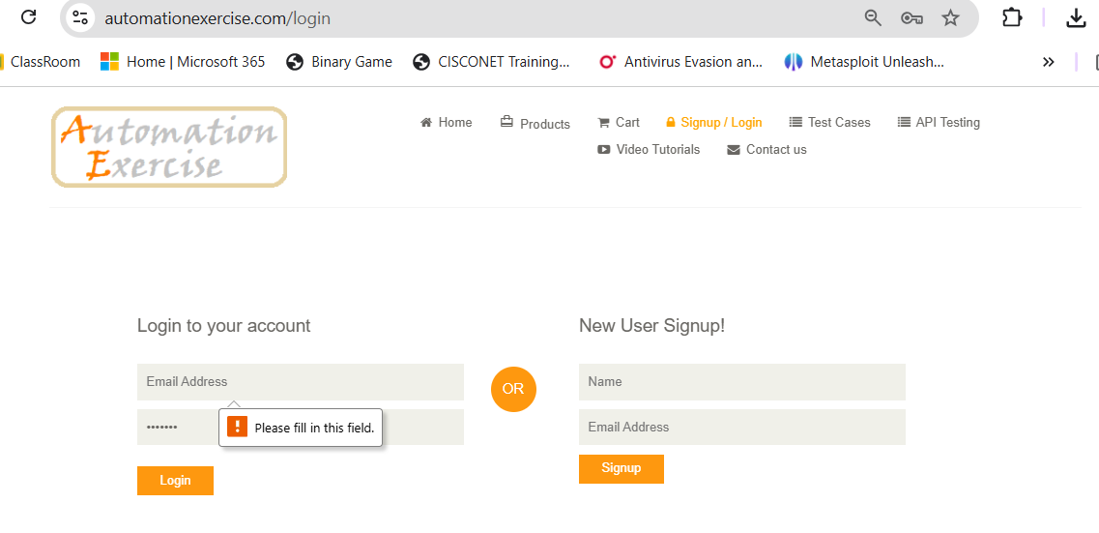

TC08 – Logout
Test Case | Check that a logged-in user can log out successfully.
Execution | Login successfully → Click Logout → Check the login page
Test Data | Valid registered account
Expected Result | The user should be logged out and returned to the login page.
Actual Result | Logout is successful and the login page is displayed again.
Status | PASS
Screenshot:

Test Execution Summary
Total Test Cases | 8
Passed | 7
Failed | 1
Blocked | 0
Pass % | 90%
Overall Result | PASS

